ATOCP Chair
C/O Association of Trauma and Orthopaedic Chartered Physiotherapists
3rd Floor South, Chancery Exchange
10 Furnivall Street
London
EC4A 1AB
atocpchair@gmail.com

February 2024

RE: ATOCP AFFILLIATE MEMBERSHIP OF THE BRISITSH ORTHOPAEDIC ASSOCIATION

This letter certifies that the applicant is a member of the Chartered Society of Physiotherapy and the Association of Trauma and Orthopaedic Chartered Physiotherapists (ATOCP). As Chairperson of the ATOCP I am writing in support of this application for Affiliate British Orthopaedic Association membership.

Please do not hesitate to contact me on the above email address if you require any further information.

Your sincerely

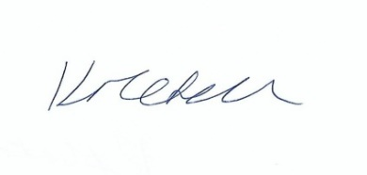

Katrina Mitchell
ATOCP Co-Chair

